**Minimalism**

Minimalism is an artistic style understood as a transition between high modernist abstraction and the turn into what would become known as postmodernism in art. Rather than a cohesive school, Minimalism is comprised of heterogeneous artistic tendencies embodied by individual practitioners. Some of its identifiable characteristics include the preference for industrial fabrication instead of handmade construction, hard-edged geometric shapes and patterns sometimes arranged as serial units, and the elimination of reference and expression. These tactics suggest that Minimal artists were less concerned with authorial intention (i.e., the meanings an artist communicates through a given artwork) and more greatly concerned with the perceptive experience of the viewer. Some Minimalist artists were also art critics and vigorous polemicists for their own work. Key figures in this movement include Carl Andre, Donald Judd, Sol LeWitt, Robert Morris, Tony Smith and Anne Truitt. At first glance, the highly reduced surface incident of Color Field painting, like that of Barnett Newman or Ad Reinhardt, might seem consonant with the advent of Minimalism. However, the relationship between Minimalism and the history of modernism is usually understood as a contradictory one, in-part due to the legacy of critic Michael Fried’s essay ‘Art and Objecthood’ (1967).

The modernist art critic Michael Fried defended modernism’s concern for the irreducible and pure essence of art against minimalism’s “theatricality.” He argued that instead of a given work’s ability to galvanize the viewer into a single and transcendental moment of attentiveness, Minimalist (which he termed “literalist”) artworks too frequently made the viewer aware of the mundane temporal and spatial conditions influencing perception. In fact, many Minimal artists eschewed a conventional base for their sculptural work to enhance this very point: that the artwork is and should be perceived as totally consistent with its viewer’s environment. For instance, in Robert Morris’s *Mirrored Cubes* (1965), the serial cubic structures literally reflect movements of the beholders in its proximate space. Such a phenomenon presented a quandary to those who wished to understand a fundamental quality in art, something that the previous generation’s avant-garde strived to express. According to the art historian Hal Foster, because Minimalism offered a critique of late modernism, it occupies a unique position in modernist genealogy as both as a culmination and an endpoint. As a culmination, Minimalist artworks propose radical questions about the conventional limits of medium. As an endpoint, Minimalism demonstrated the institutional and environmentally pre-conditioned character of aesthetic experience, rather than the autonomous character that modernism had earlier enshrined.

**References and further reading**

Battcock, G. (1968) *Minimal Art: a critical anthology*. New York: E. P. Dutton.

Chave, A. (1990) ‘Minimalism and the Rhetoric of Power’, *Arts* 64 (5): 44-63.

Colpitt, F. (1993) *Minimal Art: The Critical Perspective*. Seattle: University of Washington Press.

Foster, H. (1996) ‘The Crux of Minimalism.” *The Return of the Real: The Avant-Garde at the End of the Century*. Cambridge: The MIT Press.

Fried, M. (1967) ‘Art and Objecthood’, *Artforum* 5: 12-23.

Judd, D. (1965) ‘Specific Objects’, *Arts Yearbook* 8: 74-82.

Krauss, R. (1981) *Passages in Modern Sculpture*. Cambridge: The MIT Press.

Meyer, J. (2001) *Minimalism: Art and Polemics in the Sixties*. New Haven: Yale University Press.

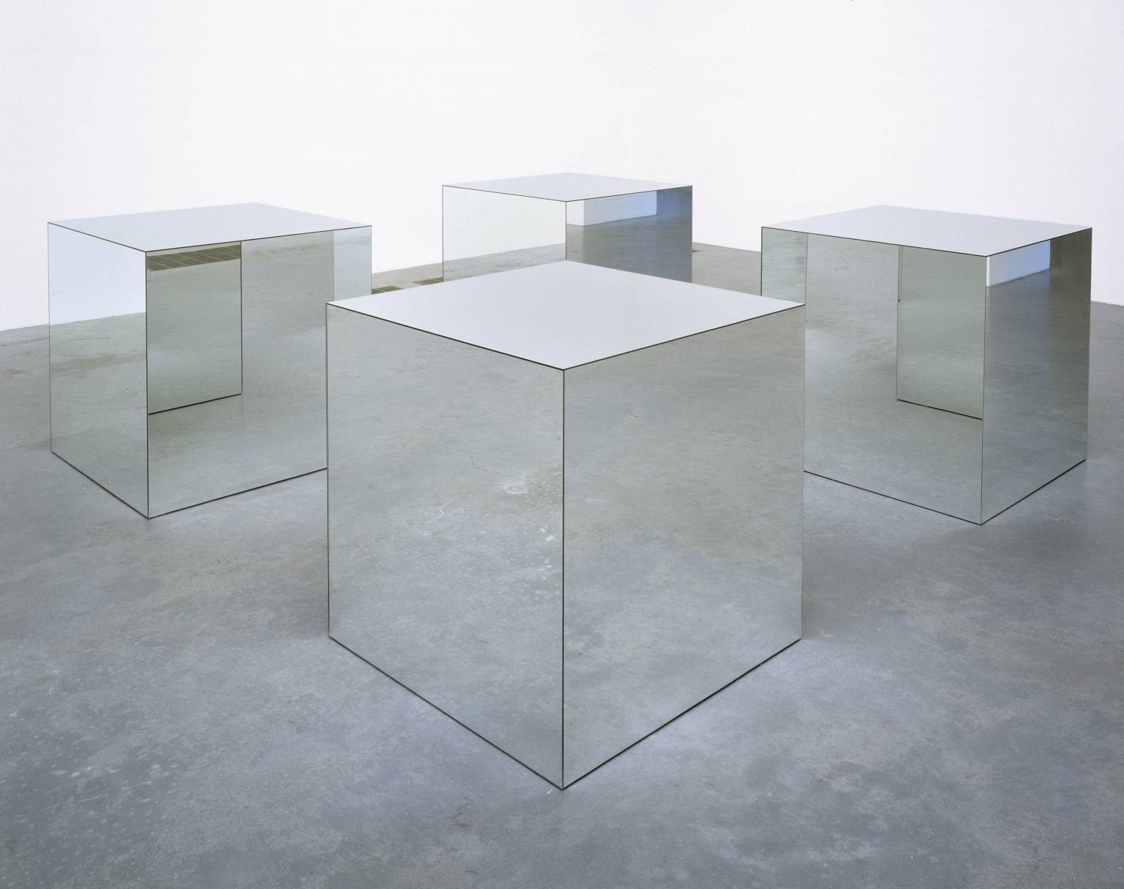

Robert Morris, *Untitled (Mirrored Cubes)*, 1971. Mirror glass and wood. 914 x 914 x 914 mm. Tate Modern. <http://www.tate.org.uk/art/artworks/morris-untitled-t01532>